
Fall 2019 Fifteenth Judicial Circuit
RECIPROCITY
Certified Civil Process Server Reciprocity Application

INSTRUCTIONS
Process Servers certified with the Eleventh Judicial Circuit (Miami-Dade County) who would like to become certified with the Fifteenth Judicial Circuit through the Reciprocity Program shall submit a complete application and provide the required supporting documentation to the Administrative Office of the Court. A checklist is attached to this application to assist in the gathering of documents. If this form does not have enough space for the answer to any question, submit the answer on a separate sheet. It is the responsibility of the applicant to provide documentation to keep his or her application current. Incomplete applications will NOT be processed.
ADMINISTRATIVE ORDERS:
- By submitting this application, the applicant certifies that he/she has read and is familiar with the Policies and Procedures for Certified Civil Process Servers found in Administrative Order 2.701-2.709. The administrative orders can be found on the Circuit’s website at www.15thcircuit.com/adminorders (series 2).
- Applicants understand and agree that Court Administration does not provide any referrals or business to the process servers and it is up to the individual process server to obtain his or her own work.
CRIMINAL HISTORY:
- You will be required to provide a criminal history report obtained through the Florida Department of Law Enforcement (“FDLE”). You can order this report (charge of $24.00) by going to https://web.fdle.state.fl.us/search/app/default.
- A copy of the FDLE report must be emailed directly from FDLE to the following email address: CAD-ProcessServer@pbcgov.org. (Remember to include the CAD and note that there are 3 s's in processserver).
- Applicants must not have any pending criminal charges. Applicants must not have been convicted of a felony or must not have been convicted of a misdemeanor involving moral turpitude or dishonesty within the last five (5) years (see Administrative Order 2.709-9/08).
- No fees will be refunded if an applicant is rejected due to the results of the criminal history check.
- Any certified process server who has new criminal charges filed against him/her in any jurisdiction must inform the Administrative Office of the Court within forty-eight (48) hours of being charged. Failure to provide such information may result in immediate suspension of the process server’s certification.

STATUTORY REQUIREMENTS: The applicant must:
- be at least eighteen (18) years of age,
- be a permanent resident of the State of Florida,
- submit to a background investigation, and
- not have a mental or legal disability (see Florida Statute 48.29).
APPLICATION DEADLINE & COSTS:

- Applications must be received no later than 4:00 p.m. on Thursday October 31, 2019.

- In addition to being mailed, applications may also be hand delivered to Court Administration Reception Monday through Friday 8:00am-5:00pm. Go to the 5th floor of the main courthouse, and dial for reception at the black phone on the sliding glass doors.
- The $350.00 application and training fee is non-refundable.

MANDATORY TRAINING/EXAMINATION:

- Process servers currently certified in the Eleventh Judicial Circuit will not have to take the process server examination, but will have to take an 8 hour training at another facility and provide proof. If the process server has not completed any trainings within the last two (2) years, they will also be required to attend the 1.5 hour renewal training course on either of the dates below:

DATES: IF YOU HAVE NOT COMPLETED A PROCESS SEVER TRAINING COURSE WITHIN THE LAST TWO (2) YEARS - Please Indicate your first choice with a 1 and your second choice with a 2.

Friday November 22, 2019 10:00 a.m. – 11:30 a.m. (arrive at 9:30 for check-in)
Jury Assembly Room

Tuesday December 3, 2019 3:00 p.m. – 4:30 p.m. (arrive at 2:30 for check-in)
Jury Assembly Room

- Process servers currently certified in Miami-Dade County will be required to submit a letter or a certificate of good standing from the Administrative Office of the Court of the Eleventh Judicial Circuit

SWEARING IN CERMONY: Applicants who have successfully completed all the requirements, have had their application approved and provided the required bond information, will be sworn in January, 2020.

Fall 2019 Fifteenth Judicial Circuit
Certified Civil Process Server
Reciprocity Applicant Checklist

Thank you for your interest in seeking reciprocity with the Fifteenth Judicial Circuit. Below you will find a checklist to assist you in ensuring that all required documents are provided to Court Administration. The following must be received by Court Administration no later than 4:00 p.m. on October 31, 2019. In addition to being mailed, applications may also be hand delivered to Court Administration Reception Monday through Friday 8:00am-5:00pm. Go to the 5th floor of the main courthouse, and dial for reception at the black phone on the sliding glass doors.

Please include a copy of this checklist when submitting the application.
Completed Application

Signed and Notarized Certified Process Server Agreement/Certificate of Good Conduct

Copy of Certificate of Good Standing from the Eleventh Judicial Circuit

Copy of driver’s license or State of Florida Identification Card

Cashier’s check or money order made payable to the Board of County Commissioners in the amount of $350.00 (no personal checks will be accepted)

FDLE criminal history report. A request can be made by going to the following website https://web.fdle.state.fl.us/search/app/default - cost $24.00.
- Results can either be mailed directly from FDLE through the United States Postal Service to Court Administration 205 North Dixie Highway, 5th Floor, West Palm Beach, Florida 33401 or
- Results can be emailed directly from FDLE to Court Administration by including the following email address in the FDLE online form:
CAD-ProcessServer@pbcgov.org
- For integrity and security purposes, email results must come DIRECTLY from FDLE and cannot be forwarded from your email. Remember there are 3 S's in the email address.
- Contact FDLE at 850-410-8109 for technical questions or issues.

After acceptance, the following must completed no later than January 10, 2020.
Obtain an original Bond in the amount of $5,000.00 with a surety company authorized to do business in Florida and bound onto the Fifteenth Judicial Circuit.

Record and obtain a Certified Copy of the recorded bond. The bond is to be recorded with the Clerk's Office Recording Department located on the 4th Floor of the courthouse. Recording and certification fees will apply.

Provide certified copy of the recorded bond to Court Administration

Fall 2019 Fifteenth Judicial Circuit
Application for Reciprocity - Certified Civil Process Server
I hereby submit my application for the certified process server program. I represent that I am over eighteen (18) years of age and am a permanent resident of the State of Florida. I further represent that I have not been convicted of a felony, whether or not adjudication was withheld. Additionally, I have not been convicted within the last five (5) years of a misdemeanor involving dishonesty or moral turpitude. I agree to submit to a criminal background check. I certify that I have read and am familiar with the Policies and Procedures for Certified Civil Process Servers found in Administrative Orders 2.701-2.709. I hereby certify that everything contained in the application package is true and correct to the best of my knowledge.
I further understand that the application information is subject to appropriate public records disclosure law and that as an applicant for certification as a process server with the Fifteenth Judicial Circuit, I must attach to this application:
- A copy of my valid Florida driver’s license or State of Florida Identification Card
- Proof of Good Standing with the Eleventh Judicial Circuit
- A cashier’s check or money order in the amount of $350.00 payable to the Board of County Commissioners for the 2016-2017 reciprocity application fee and training course.
- Proof of submission of $24.00 to Florida Department of Law Enforcement for the background check. Results of the background check are to be mailed from FDLE to Court Administration at:

April Bristow, Court Administration
205 North Dixie Highway, 5th Floor
West Palm Beach, Florida 33401

OR emailed directly from FDLE to Court Administration at the following email address:

CAD-ProcessServer@pbcgov.org

We will NOT accept an email with the results from you - it must be sent directly from FDLE.
Put CAD-ProcessServer@pbcgov.org as a recipient of the results.

Signature:

Printed Name:

Date:

Please return your completed application package to:
April Bristow, Court Administration
205 North Dixie Highway, Rm. 5.2500
West Palm Beach, Florida 33401

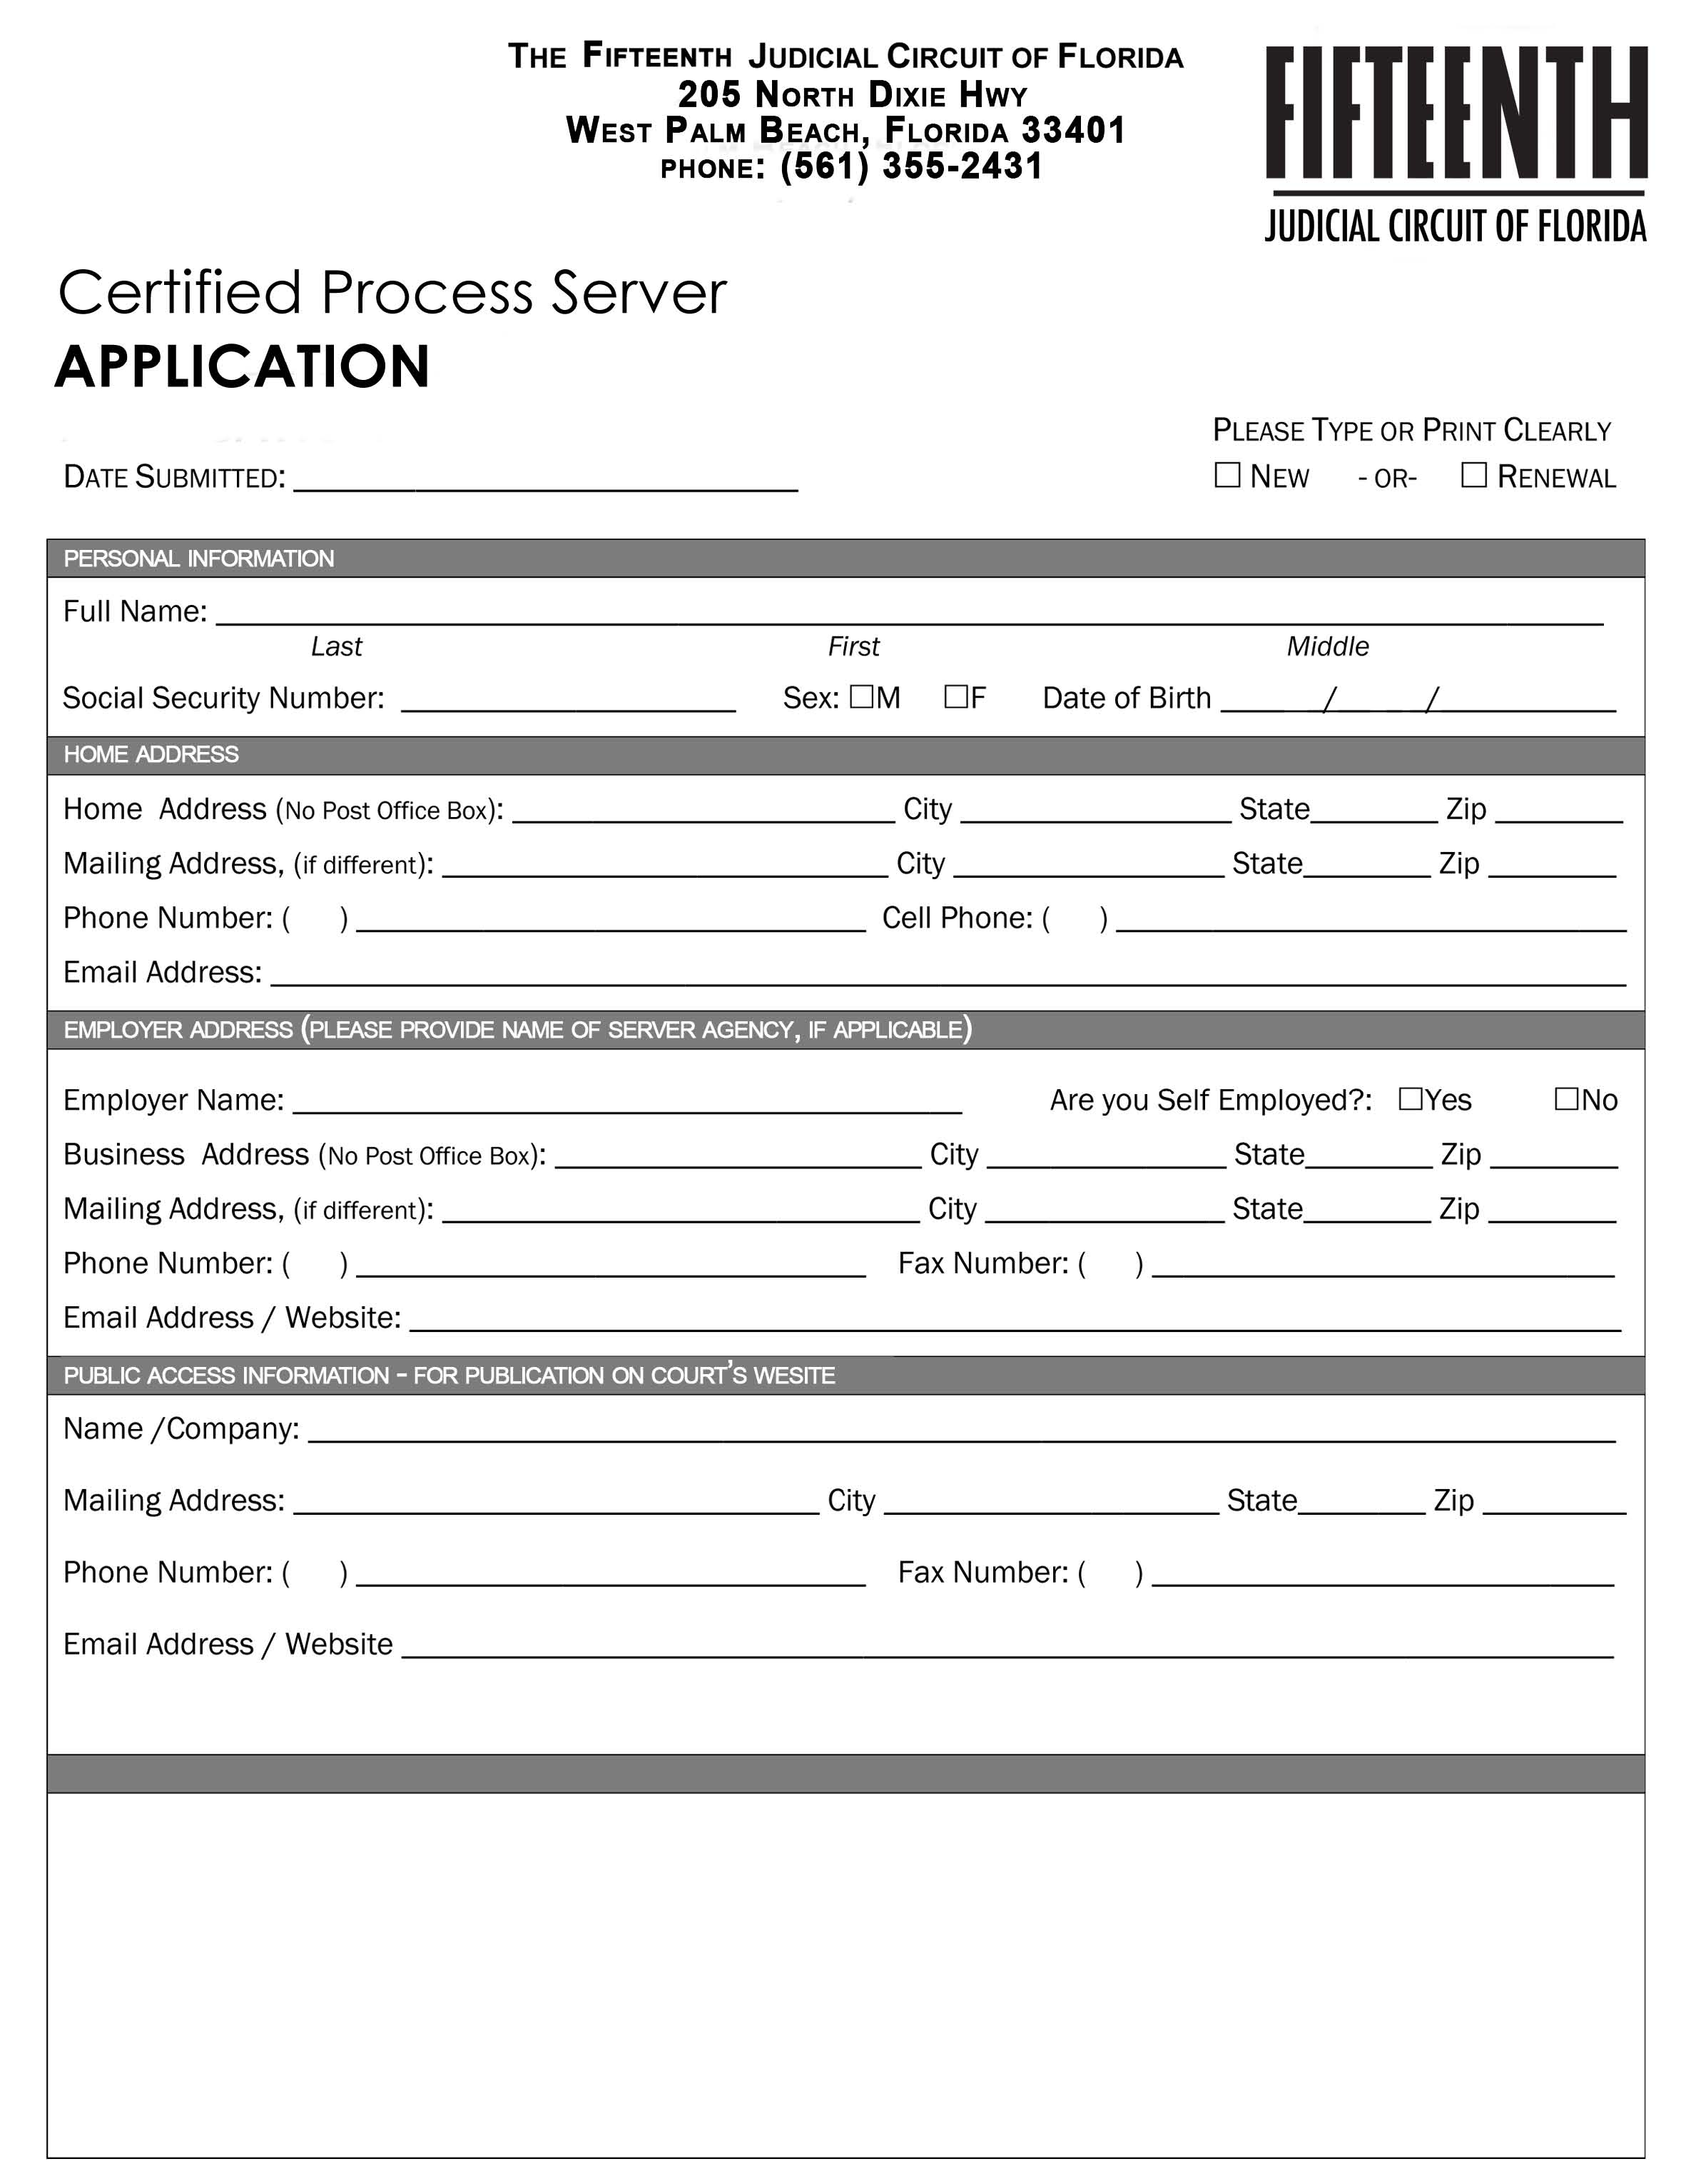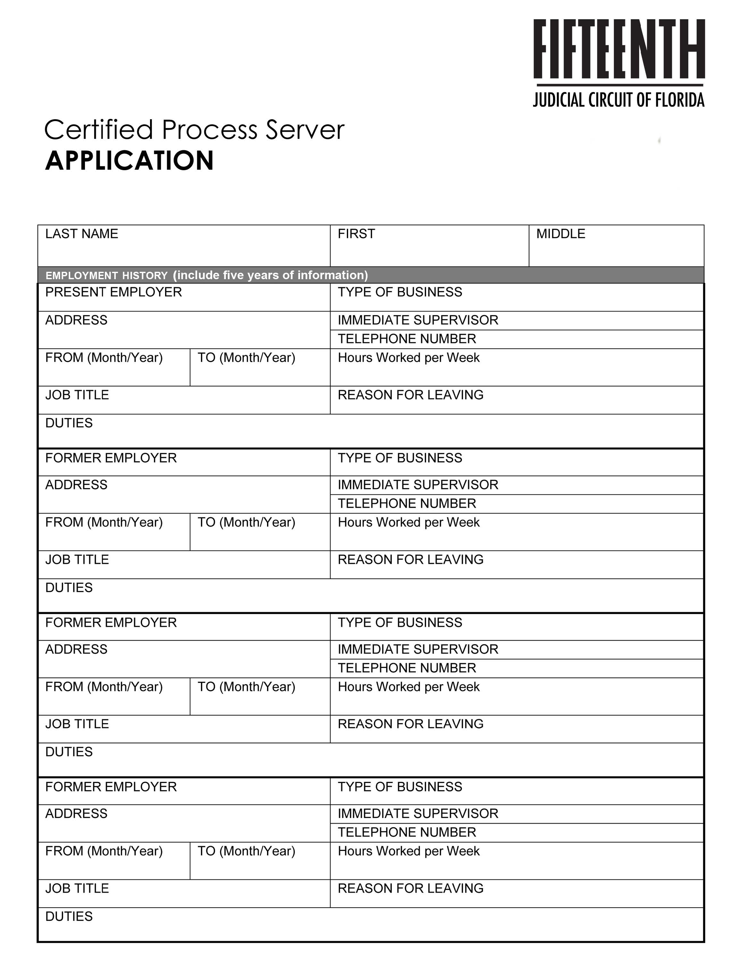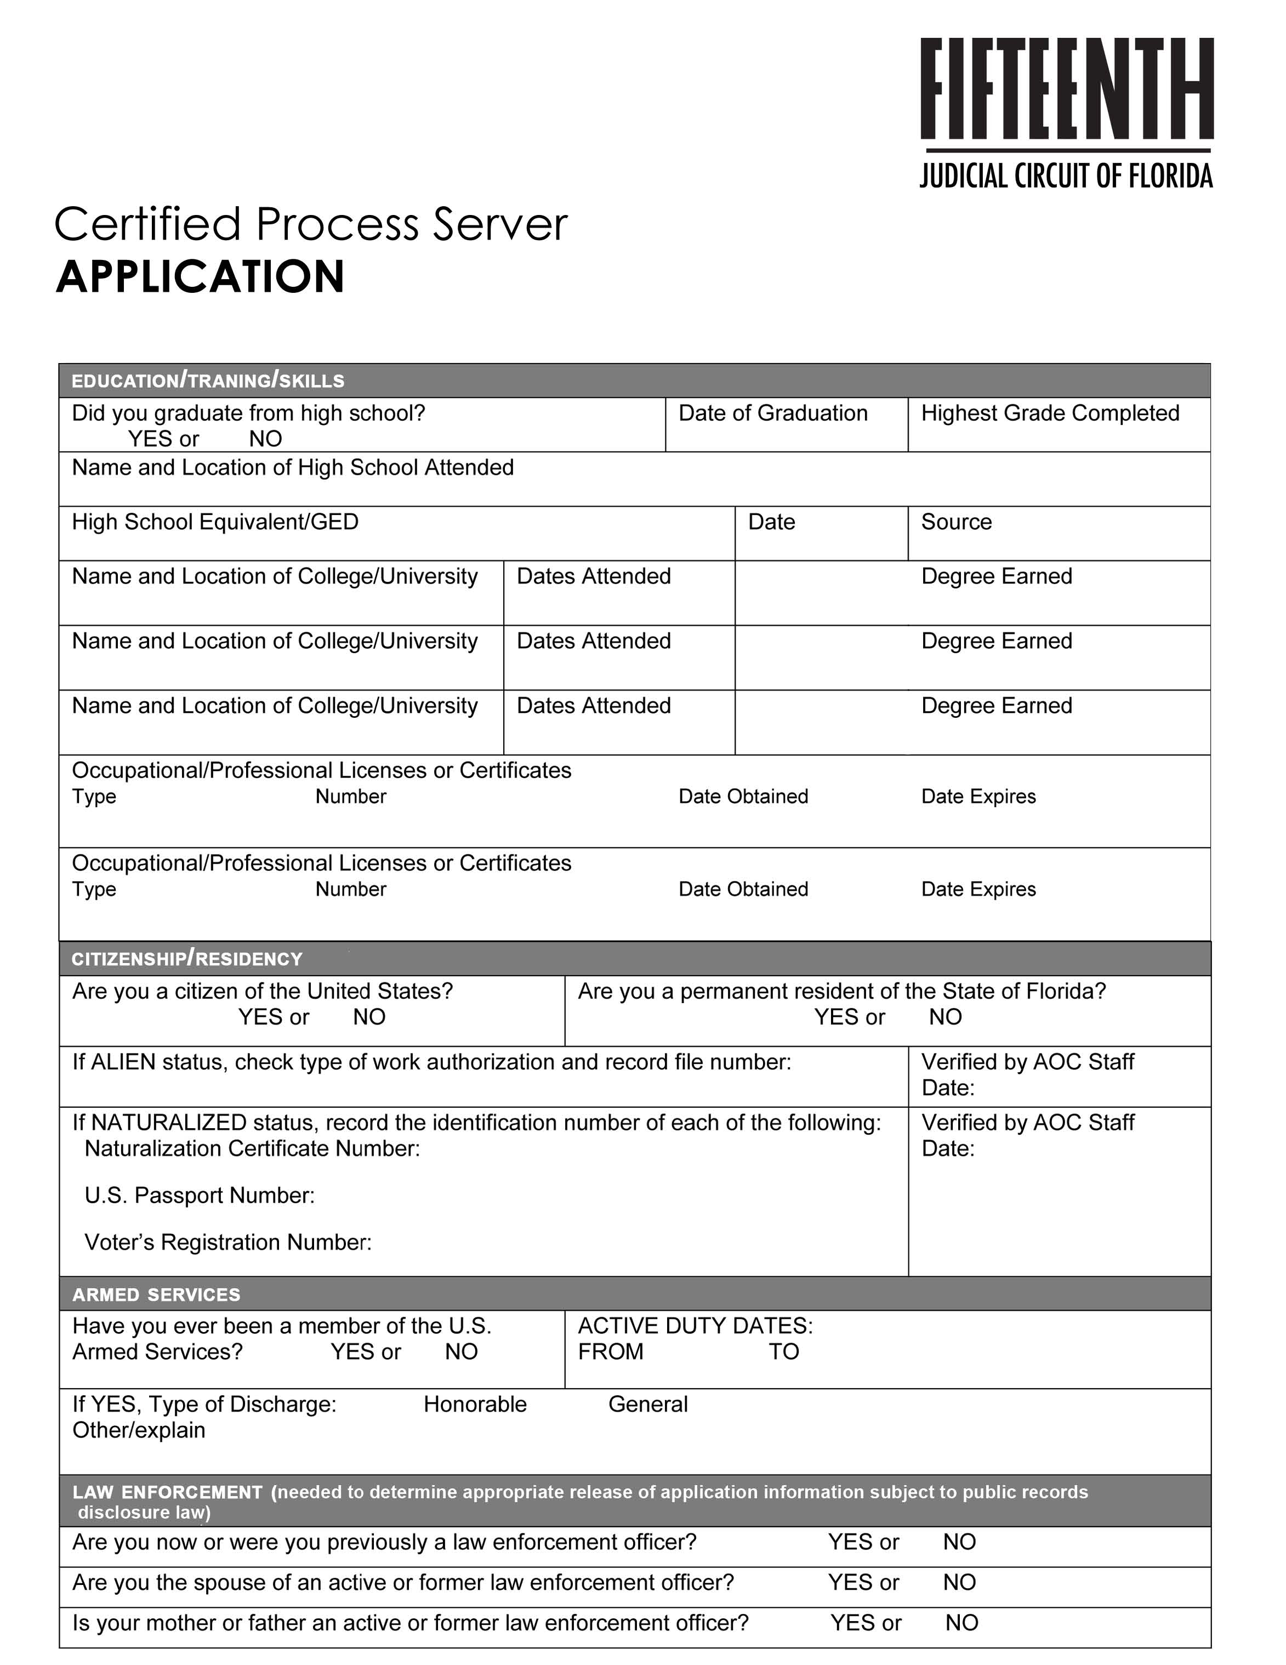
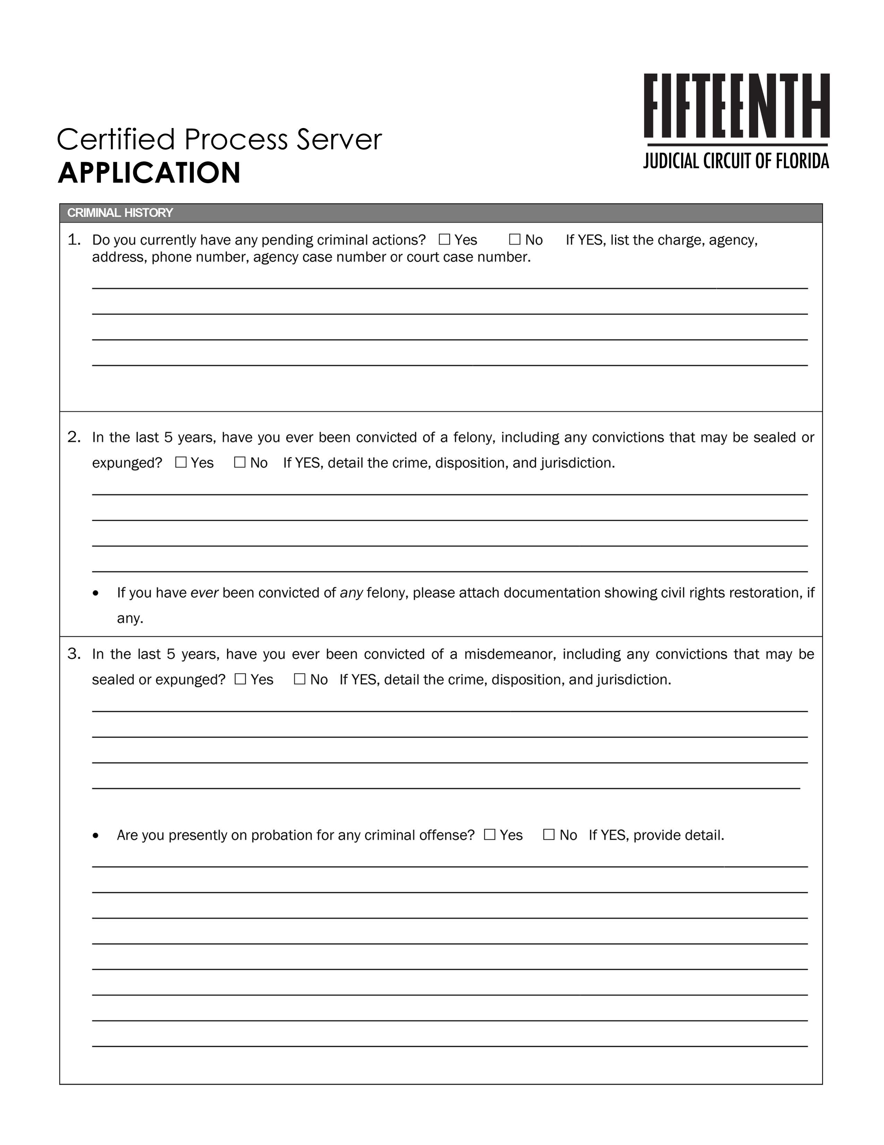

Fall 2019 Fifteenth Judicial Circuit
CERTIFIED PROCESS SERVER AGREEMENT and
CERTIFICATE OF GOOD CONDUCT

Under penalty of perjury, I swear (or affirm) that the information contained in this application is true and correct.
I will honestly, diligently and faithfully exercise the duties imposed upon me as a Certified Process Server in accordance with Chapter 48, Florida Statutes and the Orders of this Court and will abide by and effect service of process in accordance with the applicable Florida Statutes and Rules and Orders of this Court and that the information provided herein is true and correct.
Upon notification that I have successfully completed application process, I agree to execute a bond in the amount of $5,000.00 with a surety company authorized to do business in the state of Florida for the benefit of any person wrongfully injured by any malfeasance, misfeasance, neglect of duty, or incompetence on my part in connection with any duties as a process server. Furthermore, I agree to renew such a bond annually as required by the Administrative Office of the Court. I agree to submit a certified copy of the recorded bond and/or the bond continuation certificate within five (5) days of obtaining it, to the Administrative Office of the Court, Palm Beach County Courthouse. Failure to do so may result in the suspension of my certification.
I hereby agree to submit to a background investigation, which shall include the right to obtain and review any criminal record I may have. I hereby authorize the use of the information given above to assist in such investigation. I agree that my certification as a Certified Process Server may be revoked at any time if there is a material misrepresentation made in this application.
CERTIFICATE OF GOOD CONDUCT: I certify that, to the best of my knowledge, there are no pending criminal cases against me and no record of any felony conviction, nor a record of a misdemeanor involving moral turpitude or dishonesty within the past five (5) years, pursuant to Florida Statute §48.29(3)(e)
FURTHER AFFIANT SAYETH NAUGHT.
STATE OF FLORIDA COUNTY OF PALM BEACH
BEFORE ME, an officer duly authorized to administer oaths, personally appeared __________________________________, who first being duly sworn, deposes and says that he/she is the person described in and who executed the foregoing application, that he/she has read the same and the things and matters therein contained are true and correct to the best of his/her knowledge and belief. He/She is personally known to me or has presented _______________________ (type of identification) as identification.
Signature of Affiant:________________________________
Printed Name of Affiant:_____________________________
Title: Notary Public Commission Number:_______________________

